Report HW 5 ECE-111
Name: Jasper Huang
PID: A17796149

Homework 5a (Gray to Binary Code Converter)
- SystemVerilog design code
  - gray_code_to_binary_converter
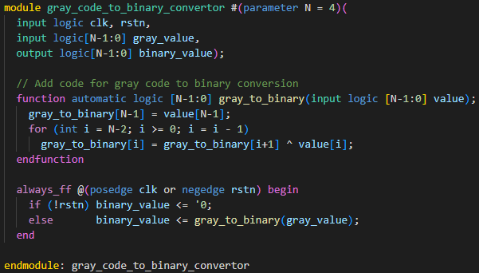
- Synthesis Resource usage and schematic generated from RTL netlist viewer
  - Resource Usage
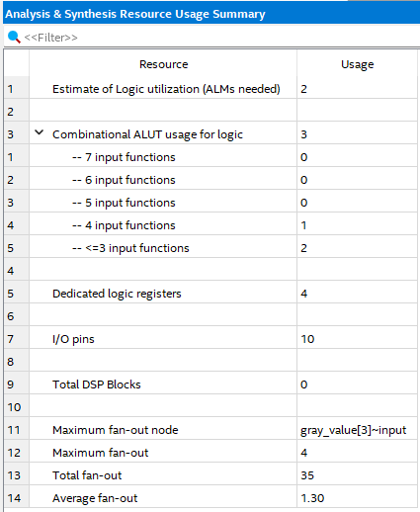
  - RTL netlist viewer
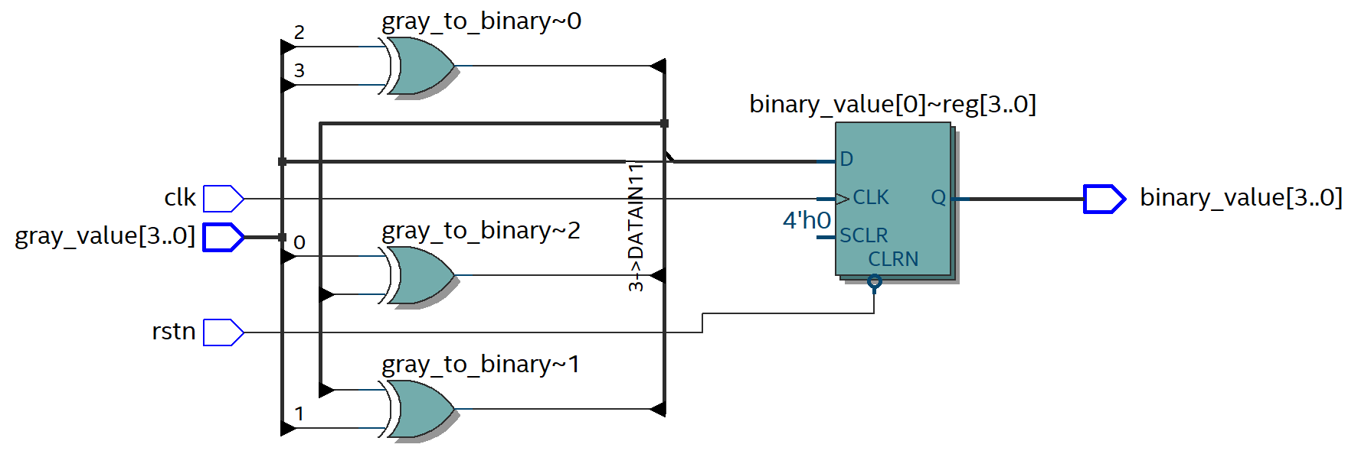
- Simulation snapshot and explain simulation result
- Post-Mapping schematic
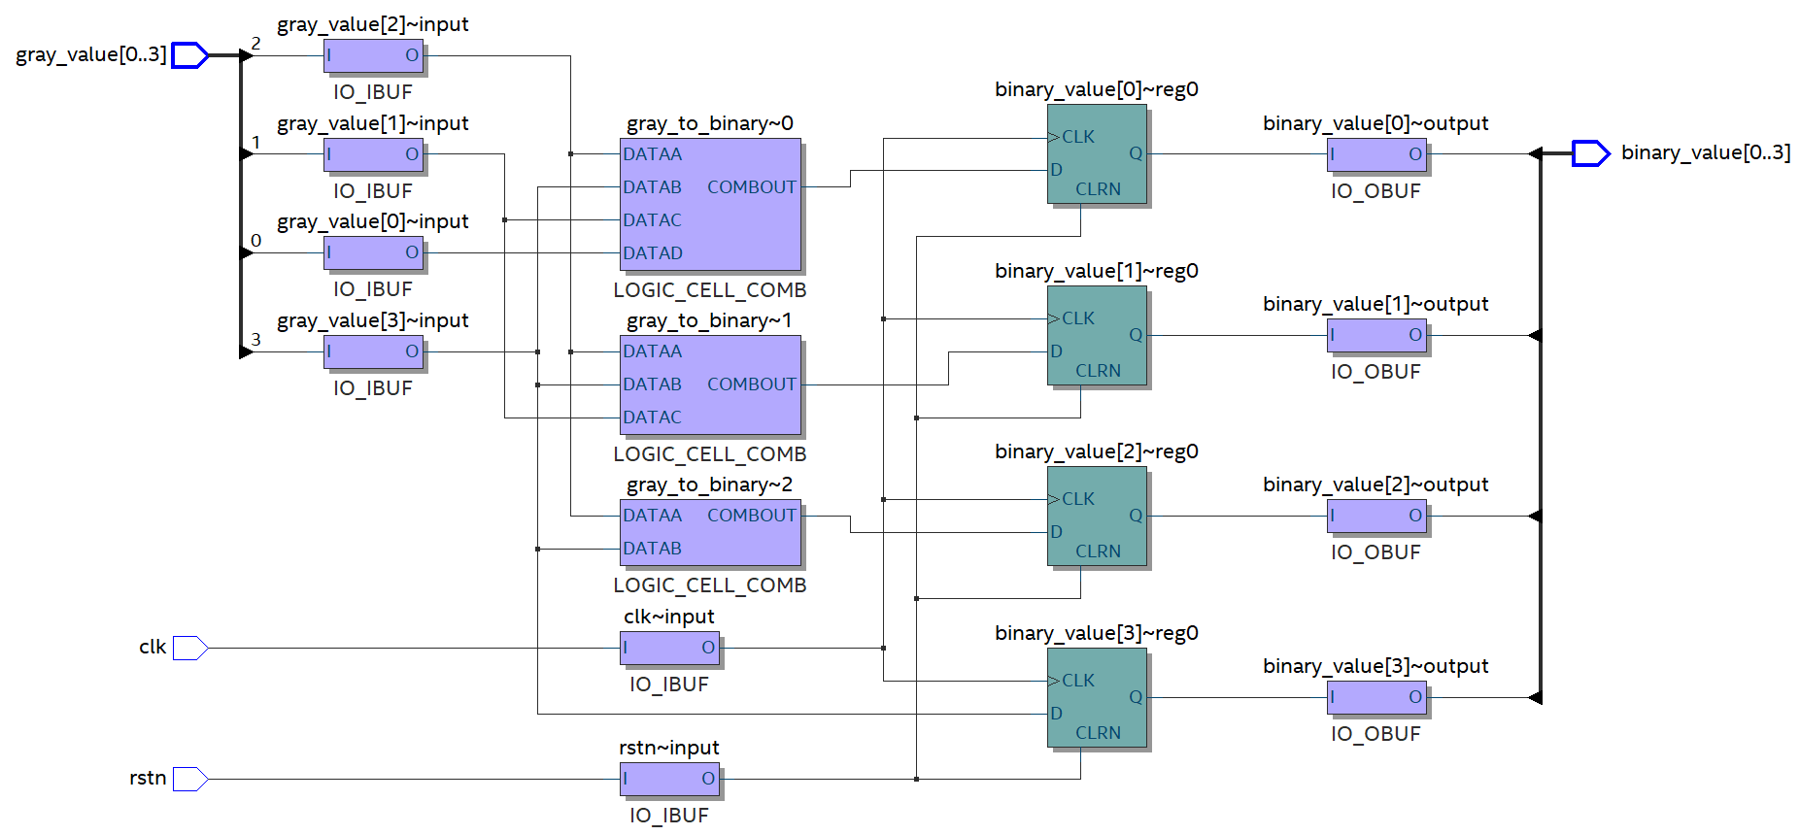

Homework 5b (Carry Lookahead Adder)
- SystemVerilog code snapshot
  - carry_lookahead_adder
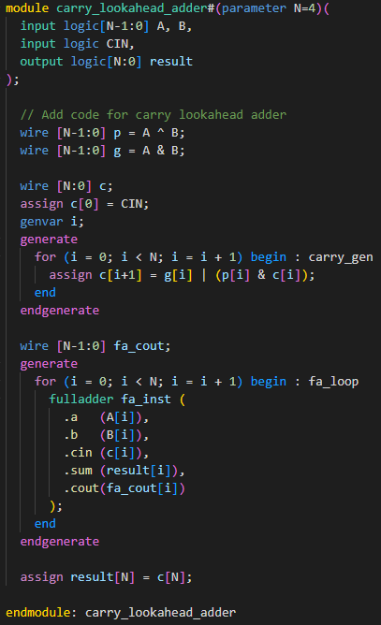
- Synthesis Resource usage and schematic generated from RTL netlist viewer
  - Synthesis Resource usage
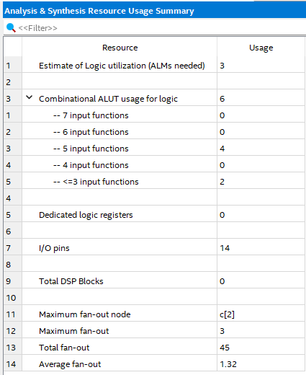
  - RTL netlist viewer
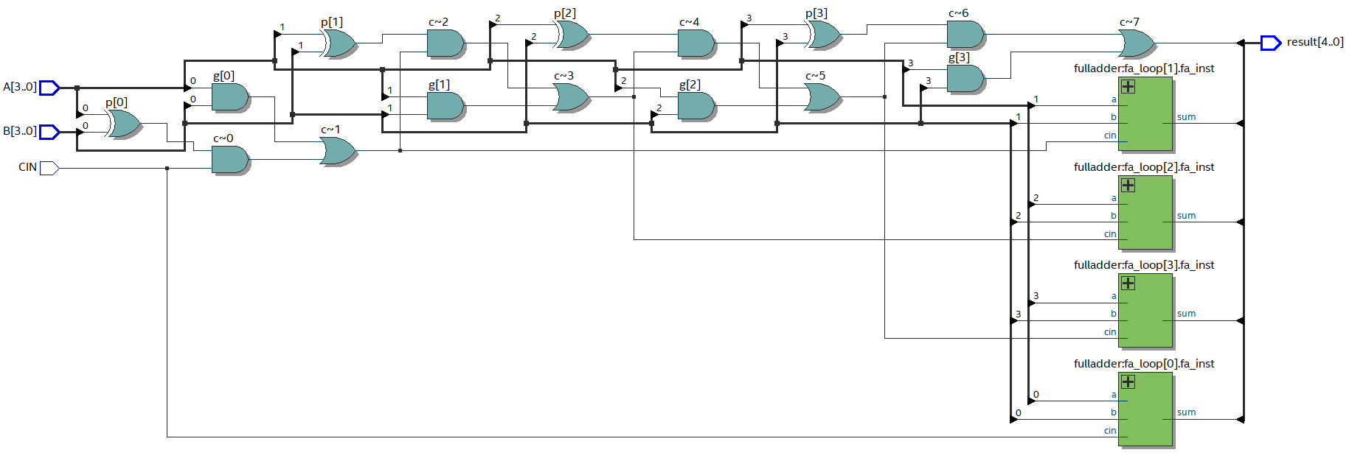

- Simulation snapshot and explain simulation result
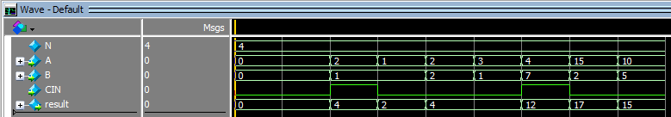
- Post-Mapping schematic
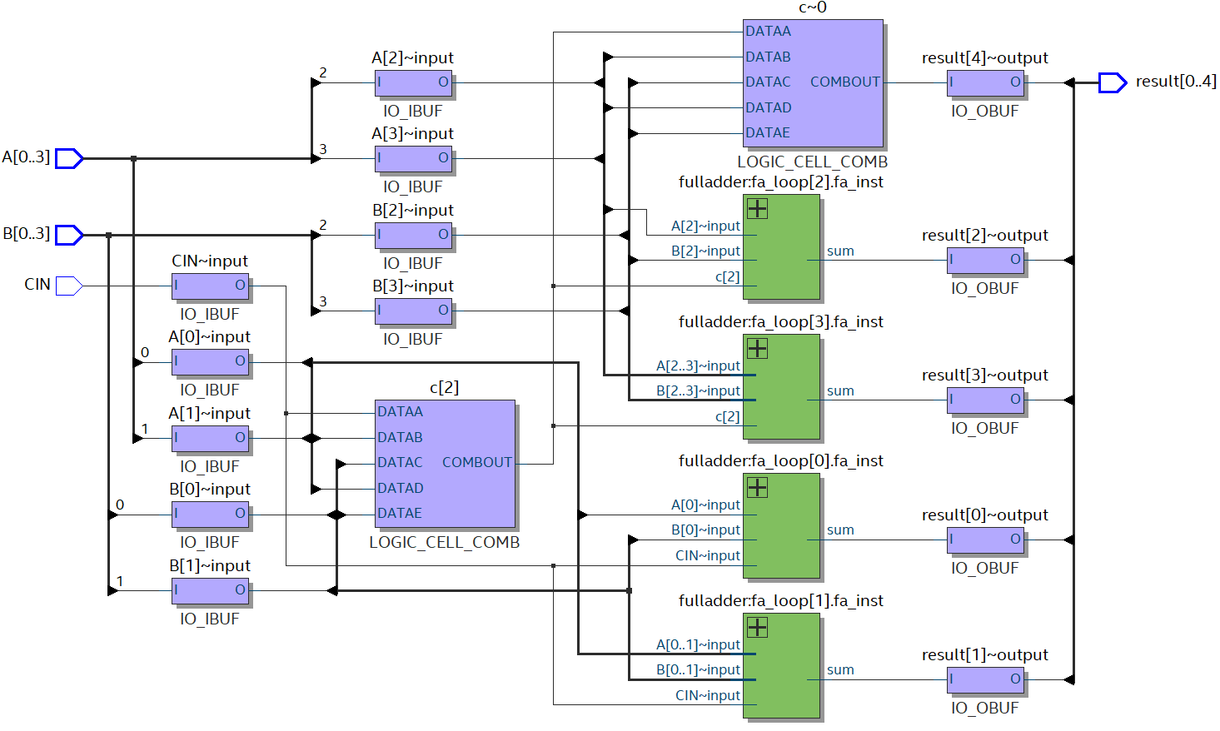

Homework 5c (ECC Encoder and ECC Decoder)
- SystemVerilog code snapshot
  - carry_lookahead_adder

- Synthesis Resource usage and schematic generated from RTL netlist viewer
  - Synthesis Resource usage

  - RTL netlist viewer

- Simulation snapshot and explain simulation result

- Post-Mapping schematic

